# AIG 130 – Lab 2 – Group 5

## Group Members:

* Masoud Masoori
* Aliyyah Jackhan
* Mohammed Aadil Suhail Shaikh
* Jonathan Chacko Pattasseril

## Introduction:

* The Growing Threat of the Dark Web
  + The Dark Web is becoming increasingly dangerous, with reports indicating a rise in illegal activities.
* The Role of AI in Cybercrime
  + With advancements in AI, cybercriminals have started using AI-powered tools for hacking, phishing, and automation of illegal activities.
* The Need for AI-Based Defense
  + To counteract AI-driven cybercrime, new AI-powered security measures are needed.
  + DarkBERT was created to understand and monitor illicit activities, helping law enforcement and cybersecurity professionals.
* Introduction to DarkBERT
  + DarkBERT, and abbreviation for Bidirectional Encoder Representations from Transformers, cutting-edge machine learning model designed to operate in the dark web environment
* Developed by South Korean Researchers
  + Researchers from South Korea developed DarkBERT to navigate the Dark Web efficiently.
* Purpose: Navigating and Analyzing the Dark Web
  + DarkBERT helps identify threats, monitor discussions, and detect potential cybercrimes.
* Training Data: 13,000+ Dark Web URLs, 1,000+ Forums
  + Trained on vast amounts of data, making it one of the most specialized AI models for Dark Web analysis
* How DarkBERT Sheds Light on the Hidden Web
  + DarkBERT can detect patterns in illicit activities and predict emerging threats before they become widespread

## Purpose and Importance

It can be used to detect and classify Dark Web content, which can be used to help Law Enforcement Agencies to detect and prevent Cyber Crimes

It can also be used to detect and prevent Cyber Crimes like Phishing, Scams, Malware, etc...

# Research

## Technology Analysis:

BERT → RoBERTa → DarkBERT

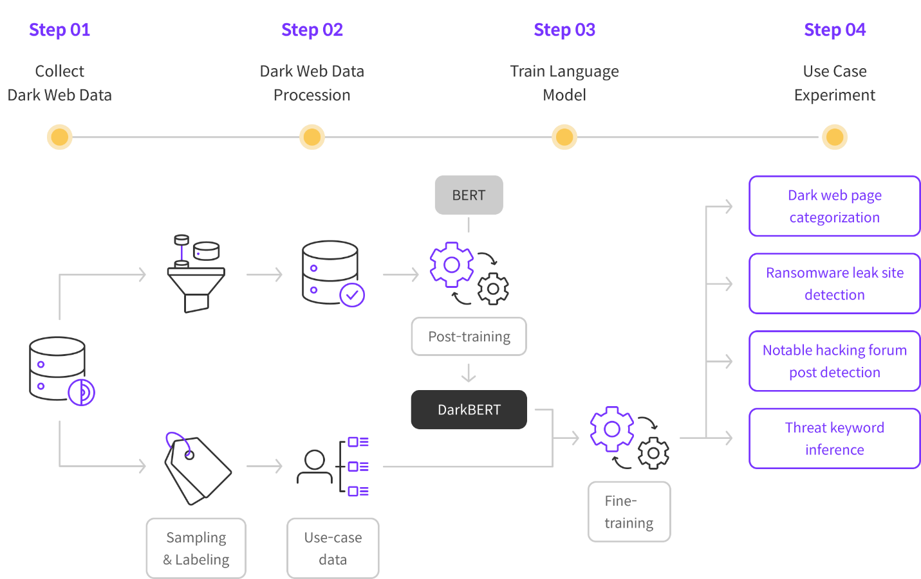

- BERT is made by Google & was Running from 2018 Onwards

- RoBERTa is an Advanced Version of BERT by Facebook

- DarkBERT is made by taking a Version of RoBERTa

## Implementation Strategy

* DarkBERT has been trained specifically to understand the illegal content present on the Dark Web
* It is trained using two models by refining RoBERTa models through MLM on sample data collected from the Dark Web
* DarkBERT utilized existing large-scale language models and further underwent post-training by incorporating specific domain data

Note: "MLM" stands for "Masked Language Model," which is a technique used in Natural Language Processing (NLP) to train AI models by having them predict missing words ("masked" words) within a sentence, relying on the context provided by the surrounding words to understand the meaning and fill in the gaps; essentially, it teaches the model to grasp the semantic relationships between words in a sentence by making it "fill in the blanks.".

### **Challenges and Solutions of Accessing and Using Dark Web Data**

1. **Accessing the Data from the Dark Web**
   1. **Challenge:** The Dark Web is structured like an onion, with multiple layers of encryption, making data access difficult.
   2. **Solution:** Use VPNs and Tor browsers to access Dark Web data.
2. **Data Collection**
   1. **Challenge:** Dark Web data is not indexed by search engines, making it hard to find.
   2. **Solution:** Utilize web scraping tools and APIs to collect data.
3. **Data Quantity**
   1. **Challenge:** The sheer volume of data makes it difficult to sort and process.
   2. **Solution:** Use big data tools like Hadoop and Spark for efficient processing.
4. **Data Deciphering**
   1. **Challenge:** Dark Web data is often encrypted and difficult to interpret.
   2. **Solution:** Apply NLP and machine learning models to decipher the data.
5. **Data Cleaning**
   1. **Challenge:** The data is often unstructured and requires extensive cleaning.
   2. **Solution:** Use data cleaning tools like Pandas and NumPy for preprocessing.
6. **Data Labeling**
   1. **Challenge:** Most Dark Web data is unlabeled, making manual labeling time-consuming and costly.
   2. **Solution:** Use crowdsourcing platforms like Amazon Mechanical Turk for labeling.
7. **Model Training**
   1. **Challenge:** Training AI models on Dark Web data requires high computational power.
   2. **Solution:** Utilize cloud-based GPUs and TPUs for efficient model training.
8. **Model Evaluation, Deployment & Maintenance**
   1. **Challenge:** Maintaining and deploying models requires significant resources.
   2. **Solution:** Use cloud platforms like Google Cloud AI for scalability.
9. **Data Privacy & Security**
   1. **Challenge:** Dark Web data is sensitive and must be protected to ensure privacy.
   2. **Solution:** Implement encryption and access control measures.
10. **Legal & Ethical Issues**

* **Challenge:** Accessing and using Dark Web data without authorization may be illegal and unethical.
* **Solution:** Ensure compliance by obtaining proper authorization and using data strictly for research purposes.

# Analysis

## Effectiveness

DarkBERT’s effectiveness lies in its specialized design for the dark web’s unique challenges, enabling superior performance compared to general-purpose models. Key factors include:

**Tailored Training**:

Trained on dark web datasets, DarkBERT understands niche jargon, slang, and coded language (e.g., drug trafficking terms, ransomware logs).

This specificity improves accuracy in detecting malicious activities like illegal transactions, cybercrime schemes, and sensitive communications.

**Threat Detection & Cybersecurity Applications**:

Identifies real-time threats such as leaked credentials, malware discussions, phishing schemes, and zero-day exploits.

Law enforcement agencies use it to trace illicit activities (e.g., weapon/drug sales, cryptocurrency scams) and map criminal networks.

**Adaptability**:

Continuously retrained on evolving dark web content (e.g., new forums, encryption methods) to stay relevant.

Case studies show success in flagging emerging ransomware groups and predicting data breaches before they surface publicly.

**Improved Search & Categorization**:

Categorizes unstructured dark web content (e.g., forums, marketplaces) more efficiently than traditional tools, streamlining investigations.

**Reduced False Positives**:

Contextual understanding minimizes errors in flagging benign activities as malicious, improving trust in outputs.

**Anonymity & Privacy Handling**:

Processes noisy, unstructured data (misspellings, CAPTCHAs, Tor network content) to extract actionable insights while respecting anonymity challenges.

## Cost-Benefit Analysis

#### Costs:

**Development Costs**:

High computational resources (GPUs/TPUs) and large-scale dark web datasets are required for training.

Legal/ethical risks arise from scraping illegal content (e.g., drug markets, exploit sales).

**Data Acquisition**:

Anti-crawling measures (IP blocking, CAPTCHAs) make data collection resource-intensive.

Requires strict compliance frameworks to avoid legal liabilities.

**Maintenance & Updates**:

Rapid evolution of dark web language and infrastructure demands frequent retraining, incurring ongoing costs.

**Potential Misuse**:

If weaponized, DarkBERT could enhance malicious activities (e.g., automating phishing campaigns, evading detection).

**Ethical Dilemmas**:

Balancing privacy rights (e.g., anonymity of dark web users) with public safety goals is contentious.

#### Benefits:

**Proactive Threat Mitigation**:

Early detection of cyberattacks, data leaks, or ransomware plans prevents financial/reputational damage. For example, identifying a zero-day exploit early could save millions in losses.

**Operational Efficiency**:

Automates manual tasks (e.g., monitoring forums, analyzing logs), freeing cybersecurity teams to focus on strategic responses.

Scales threat detection across vast dark web ecosystems.

**Law Enforcement Support**:

Accelerates investigations by mapping relationships between entities (vendors, buyers) and predicting criminal trends.

**Cost Savings**:

Preventing a single major attack (e.g., ransomware) can offset years of development costs.

**Broader Impact**:

Strengthens global cybersecurity frameworks by improving dark web analysis capabilities, fostering safer digital ecosystems.

***Trade-offs & Considerations***:

**False Positives/Negatives**: Over-reliance on automation risks missing nuanced threats (e.g., steganography) or misclassifying content. Human oversight remains critical.

**Ethical Governance**: Transparent frameworks are needed to ensure responsible use and avoid privacy violations.

**Complementary Human Expertise**: DarkBERT augments—but does not replace—human analysts who interpret context and make strategic decisions.

## Impact Assessment

1. Innovation :

* Pioneering AI in Cybersecurity
* Continuous Learning and Adaptation
* Collaboration Between AI and Human Expertise

1. Improvements in Efficiency :

* Enhanced Threat Detection
* Automation of Repetitive Tasks
* Scalability

1. Customer Satisfaction :

* Proactive Cybersecurity
* Reduced Downtime
* Tailored Solutions

# Usage

1. Dark Web Page Classification
2. Ransomware Leakage Site Detection
3. Detection of Key Threads
4. Inference of Threat Keywords

# Conclusion

DarkBERT’s domain-specific training and adaptability make it a powerful tool for combating dark web threats, offering unmatched efficiency in threat detection and investigation. While development costs, ethical risks, and maintenance demands are significant, the long-term benefits—proactive cybersecurity, cost savings, and enhanced law enforcement capabilities—justify its adoption. Success hinges on balancing automation with human oversight, maintaining ethical rigor, and investing in continuous updates to stay ahead of evolving threats.

# REFERENCES:

[1] AI, N. (2024, May 23). Introducing RoBERTa base model: A comprehensive overview. *Medium.* <https://medium.com/@marketing_novita.ai/introducing-roberta-base-model-a-comprehensive-overview-330338afa082>

[2] AI. S2W. (2024). *Technology - TC01.* S2W. <https://s2w.inc/en/technology/tc01>

[3] GeeksforGeeks. (2023, January 10). Overview of RoBERTa model. *GeeksforGeeks.* <https://www.geeksforgeeks.org/overview-of-roberta-model/>

[4] Jin, Y., Jang, E., Cui, J., Chung, J.-W., Lee, Y., & Shin, S. (2023, May 18). DarkBERT: A language model for the dark side of the internet. *ArXiv.* Seongnam, South Korea.

[5] S2W. (2023, May 18). [Part 1] Getting to know DarkBERT: A language model for the dark side of the internet. *Medium.* <https://medium.com/s2wblog/part1-getting-to-know-darkbert-a-language-model-for-the-dark-side-of-the-internet-7c4c178faf3d>

[6] Srivastava, Y. (2023, December 24). Meet DarkBERT: New AI trained on the dark web. *GeeksforGeeks.* <https://www.geeksforgeeks.org/darkbert-new-ai-trained-on-the-dark-web/>